**Libraries**

The database holds information for a network of libraries, including information about the authors, titles, publishers, its members (users) as well as the physical copies in the libraries themselves

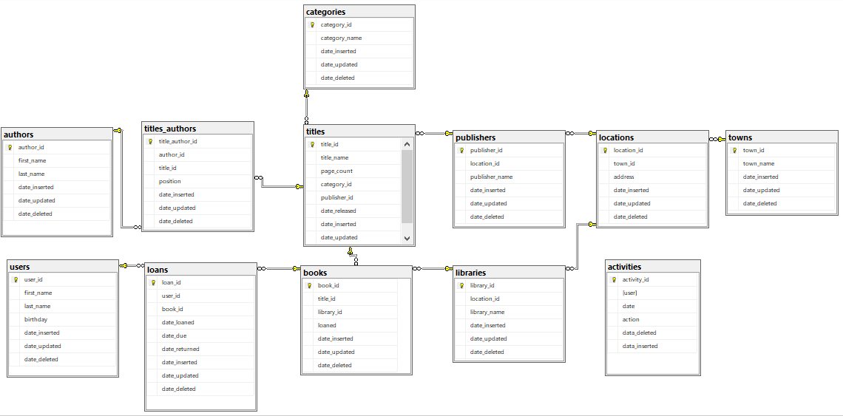

Table: authors 1

Table: titles 2

Table: titles_authors 3

Table: categories 4

Table: publishers 5

Table: locations 6

Table: towns 7

Table: libraries 8

Table: books 9

Table: loans 10

Table: users 11

# Table: authors

Columns:

author_id INT PK

first_name NVARCHAR(50)

last_name NVARCHAR(50)

date_inserted DATETIME

date_updated DATETIME NULL

date_deleted DATETIME NULL

This table stores information about authors, namely, their first and last name as well as a location_id from the locations table which stores their location

Links:

This table is linked to the titles_authors table which stores author cover positions/order on titles

Views:

dbo.authors_data shows all data about the authors without the control columns (date deleted, updated, inserted)

dbo.author_more_than_one_title shows the author id, first name and last name of authors who authored more than one title

Triggers:

author_insert logs the insertion into the activities table

author_delete changes the date_deleted column instead of deleting and logs the deletion into the activites table

author_update changes the date_updated column after updating and logs the update into the activites table

Stored procedures:

select_authors shows all non-control columns for all authors

select_author takes in a author_id and shows all non-control columns from authors for that author

insert_author takes in a first_name and last_name and inserts into the authors table

delete_author takes in an author_id and deletes the author

update_author takes in an author_id, first_name and last_name and updates the author with the author_id with the new values

# Table: titles

Columns:

title_id INT PK

title_name NVARCHAR(255)

page_count INT

category_id INT FK

publisher_id INT FK

date_released DATE

date_inserted DATETIME

date_updated DATETIME NULL

date_deleted DATETIME NULL

This table stores information about titles, namely, their name, page count, category id from the categories table as well as a publisher id from the publishers table which stores information about publishers

Links:

This table is linked to the titles_authors table which stores author cover positions/order on titles

This table is linked to the books table which stores information about physical copies of titles

This table is linked to the categories table which stores information about categories

This table is linked to the publishers table which stores information about publishers

Views:

dbo.titles_data shows all data about the titles without the control columns (date deleted, updated, inserted)

dbo.titles_without_copies shows all non-control data about titles that have no physical copies of them

dbo.books_on_loan shows the title of books, the user they are loaned to, as well as the ID of the books loaned

Functions:

dbo.titlesPublished takes the name of a publisher and returns the number of titles they’ve published

Triggers:

title_insert logs the insertion into the activities table

title_delete changes the date_deleted column instead of deleting and logs the deletion into the activites table

title_update changes the date_updated column after updating and logs the update into the activites table

Stored procedures:

select_titles shows all non-control columns for all titles

select_title takes in a title_id and shows all non-control columns from titles for that title

insert_title takes in a title_name, page_count, category_id, publisher_id and date_released and inserts into the titles table (if the page_count is at least 10 and the release date is not in the future)

delete_title takes in a title_id and deletes the title

update_title takes in a title_id, title_name, page_count, category_id, publisher_id and date_released and updates the title with the title_id with the new values (if the page_count is at least 10 and the release date is not in the future)

# Table: titles_authors

Columns:

title_author_id INT PK

author_id INT FK

title_id INT FK

position TINYINT

date_inserted DATETIME

date_updated *DATETIME* NULL

date_deleted DATETIME NULL

This table stores author cover positions/order on titles.

Links:

This table is linked to the authors table which stores information about authors

This table is linked to the titles table which stores information about titles

Views:

dbo.titles_authors_data shows all data from the title_authors table without the control columns (date deleted, updated, inserted)

dbo.author_more_than_one_title shows the author id, first name and last name of authors who authored more than one title

Triggers:

title_author_insert logs the insertion into the activities table

title_author_delete changes the date_deleted column instead of deleting and logs the deletion into the activites table

title_author_update changes the date_updated column after updating and logs the update into the activites table

Stored procedures:

select_titles_authors shows all non-control columns for all titles_authors

select_title_author takes in a title_author_id and shows all non-control columns from titles_authors for that title_author

insert_title_author takes in an author_id, title_id and position and inserts into the titles_authors table

delete_title_author takes in a title_author_id and deletes the appropriate title_author

update_title_author takes in an title_author_id, author_id, title_id and position and updates the title_author with the title_author_id with the new values

# Table: categories

Columns:

category_id INT PK

category_name NVARCHAR(255)

date_inserted DATETIME

date_updated DATETIME NULL

date_deleted DATETIME NULL

This table stores category names for autofill purposes

Links:

This table is linked to the titles table which stores information about titles

Views:

dbo.categories_data shows all data from the categories table without the control columns (date deleted, updated, inserted)

Functions:

dbo.showTitlesOfCategory takes in a category ID and returns a table with all titles from that category

Triggers:

category_insert logs the insertion into the activities table

category_delete changes the date_deleted column instead of deleting and logs the deletion into the activites table

category_update changes the date_updated column after updating and logs the update into the activites table

Stored procedures:

select_categories shows all non-control columns for all categories

select_category takes in a category_id and shows all non-control columns from categories for that category

insert_category takes in a category_name and inserts into the categories table

delete_category takes in a category_id and deletes the appropriate category

update_category takes in a category_id and category_name and sets the category_name of that category to the new one

# Table: publishers

Columns:

publisher_id INT PK

publisher_name NVARCHAR(255)

location_id INT FK

date_inserted DATETIME

date_updated DATETIME NULL

date_deleted DATETIME NULL

This table stores the names of publishers as well as well as a location_id from the locations table which stores their location

Links:

This table is linked to the titles table which stores information about titles

This table is linked to the locations table which stores locations

Views:

dbo.publishers_data shows all data from the publishers table without the control columns (date deleted, updated, inserted)

dbo.publishers_from_belgrade shows all data from the publishers table without the control columns for publishers from Belgrade

Functions:

dbo.titlesPublished takes the name of a publisher and returns the number of titles they’ve published

Triggers:

publishers_insert logs the insertion into the activities table

publishers_delete changes the date_deleted column instead of deleting and logs the deletion into the activites table

publishers_update changes the date_updated column after updating and logs the update into the activites table

Stored procedures:

select_publishers shows all non-control columns for all publishers

select_publisher takes in a publisher_id and shows all non-control columns from publishers for that publisher

insert_publisher takes in a publisher_name and location_id and inserts into the publishers table

delete_publisher takes in a publisher_id and deletes the publisher

update_publisher takes in a publisher_id , publisher_name and location_id and updates the publisher with the publisher_id with the new values

# Table: locations

Columns:

location_id INT PK

town_id INT FK

address NVARCHAR(255)

date_inserted DATETIME

date_updated DATETIME NULL

date_deleted DATETIME NULL

This table serves as a link between the publishers/ibraries tables on one side and the towns table on the other, it also stores the addresses of the above mentioned.

Links:

This table is linked to the publishers table

This table is linked to the libraries table

This table is linked to the towns table

Views:

dbo.locations_data shows all data from the locations table without the control columns (date deleted, updated, inserted)

dbo.publishers_from_belgrade shows all data from the publishers table without the control columns for publishers from Belgrade

dbo.libraries_in_belgrade shows all data from the libraries table without the control columns for libraries in Belgrade

Functions:

dbo.showLibraryAddress takes in the name of a library and returns its address

Triggers:

location_insert logs the insertion into the activities table

location_delete changes the date_deleted column instead of deleting and logs the deletion into the activites table

location_update changes the date_updated column after updating and logs the update into the activites table

Stored procedures:

select_locations shows all non-control columns for all locations

select_location takes in a location_id and shows all non-control columns from locations for that location

insert_location takes in a town_id and address and inserts into the locations table

delete_location takes in a location_id and deletes the location

update_location takes in a location_id , address and town_id and updates the location with the location_id with the new values

# Table: towns

Columns:

town_id INT PK

town_name NVARCHAR(50)

date_inserted DATETIME

date_updated DATETIME NULL

date_deleted DATETIME NULL

This table stores the names of towns for autofill purposes

Links:

This table is linked to the locations table

Views:

dbo.towns_data shows all data from the towns table without the control columns (date deleted, updated, inserted)

dbo.publishers_from_belgrade shows all data from the publishers table without the control columns for publishers from Belgrade

dbo.libraries_in_belgrade shows all data from the libraries table without the control columns for libraries in Belgrade

Triggers:

town_insert logs the insertion into the activities table

town_delete changes the date_deleted column instead of deleting and logs the deletion into the activites table

town_update changes the date_updated column after updating and logs the update into the activites table

Stored procedures:

select_towns shows all non-control columns for all towns

select_town takes in a town_id and shows all non-control columns from towns for that town

insert_town takes in a town_name and inserts into the towns table

delete_town takes in a town_id and deletes the appropriate town

update_town takes in a town_id and town_name updates the town with the town_id with the new values

# Table: libraries

Columns:

library_id INT PK

library_name NVARCHAR(255)

location_id INT FK

date_inserted DATETIME

date_updated DATETIME NULL

date_deleted DATETIME NULL

This table stores the names of libraries as well as well as a location_id from the locations table which stores their location

Links:

This table is linked to the locations table

This table is linked to the books table

Views:

dbo.libraries_data shows all data from the libraries table without the control columns (date deleted, updated, inserted)

dbo.libraries_in_belgrade shows all data from the libraries table without the control columns for libraries in Belgrade

Functions:

dbo.showLibraryAddress takes in the name of a library and returns its address

Triggers:

library_insert logs the insertion into the activities table

library_delete changes the date_deleted column instead of deleting and logs the deletion into the activites table

library_update changes the date_updated column after updating and logs the update into the activites table

Stored procedures:

select_libraries shows all non-control columns for all libraries

select_library takes in a library_id and shows all non-control columns from libraries for that library

insert_library takes in a library_name and location_id and inserts into the libraries table

delete_library takes in a library_id and deletes the appropriate library

update_library takes in a library_id, library_name and location_id and updates the library with the library_id with the new values

# Table: books

Columns:

book_id INT PK

library_id INT FK

title_id INT FK

loaned BIT

date_inserted DATETIME

date_updated DATETIME NULL

date_deleted DATETIME NULL

This table stores information about the physical copies of titles, including the id of the library the copy is in and the title

Links:

This table is linked to the libraries table

This table is linked to the titles table

This table is linked to the loans table

Views:

dbo.books_data shows all data from the books table without the control columns (date deleted, updated, inserted)

dbo.books_on_loan shows the title of books, the user they are loaned to, as well as the ID of the books loaned

dbo.titles_without_copies shows all non-control data about titles that have no physical copies of them

Triggers:

book_insert logs the insertion into the activities table

book_delete changes the date_deleted column instead of deleting and logs the deletion into the activites table

book_update changes the date_updated column after updating and logs the update into the activites table

Stored procedures:

select_books shows all non-control columns for all books

select_book takes in a book_id and shows all non-control columns from books for that book

insert_book takes in a title_id and library_id and inserts into the books table

delete_book takes in a book_id and deletes the appropriate book

update_book takes in a book_id, library_id, title_id and loaned (bit) and updates the book with the book_id with the new values

# Table: loans

Columns:

loan_id INT PK

book_id INT FK

user_id INT FK

date_loaned DATETIME

date_due DATETIME

date_returned DATETIME NULL

date_inserted DATETIME

date_updated DATETIME NULL

date_deleted DATETIME NULL

This table stores information about books on loan, including the id of the book, the user who the book is loaned to, when the book was loaned, when the book is due to be returned and when it was returned (if it was)

Links:

This table is linked to the books table

This table is linked to the users table

Views:

dbo.loans_data shows all data from the loans table without the control columns (date deleted, updated, inserted)

dbo.books_on_loan shows the title of books, the user they are loaned to, as well as the ID of the books loaned

Triggers:

loan_insert logs the insertion into the activities table

loan_delete changes the date_deleted column instead of deleting and logs the deletion into the activites table

loan_update changes the date_updated column after updating and logs the update into the activites table

loan_give after the loan is inserted, changes the ‘loaned’ value for the book to true

loan_return after the date_returned column is updated, changes the ‘loaned’ value for the book to false

Stored procedures:

select_loans shows all non-control columns for all loans

select_loan takes in a loan_id and shows all non-control columns from loans for that loan

insert_loan takes in a book_id and user_id and inserts into the loans table

delete_loan takes in a loan_id and deletes the appropriate loan

update_loan takes in a loan_id, book_id, user_id, title_id, date_loaned, date_due and date_returned and updates the loan with the loan_id with the new values

# Table: users

Columns:

user_id INT PK

first_name NVARCHAR(50)

last_name NVARCHAR(50)

birthday DATETIME

date_inserted DATE

date_updated DATETIME NULL

date_deleted DATETIME NULL

This table stores information about users

Links:

This table is linked to the loans table

Views:

dbo.users_data shows all data from the users table without the control columns (date deleted, updated, inserted)

dbo.books_on_loan shows the title of books, the user they are loaned to, as well as the ID of the books loaned

Triggers:

user_insert logs the insertion into the activities table

user_delete changes the date_deleted column instead of deleting and logs the deletion into the activites table

user_update changes the date_updated column after updating and logs the update into the activites table

Stored procedures:

select_users shows all non-control columns for all users

select_user takes in a user_id and shows all non-control columns from users for that user

insert_user takes ina first_name, last_name and birthday and inserts into the users table

delete_user takes in a user_id and deletes the appropriate user

update_user takes in a user_id, first_name, last_name,and birthday and updates the user with the user_id with the new values